**Sirkuit 1 (2–3 set)**:

* Bodyweight Squat – 15x

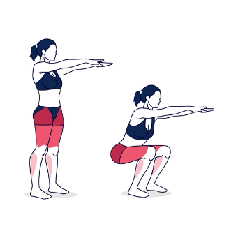

* Glute Bridge – 15x

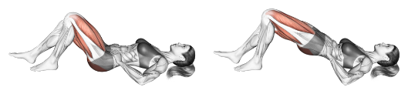

* Wall Sit – 30 detik

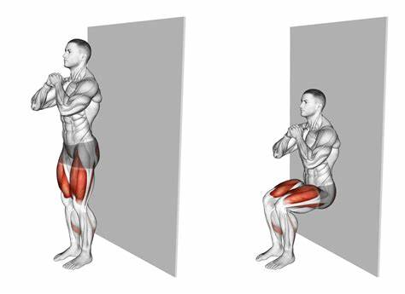

* Standing Calf Raise – 20x

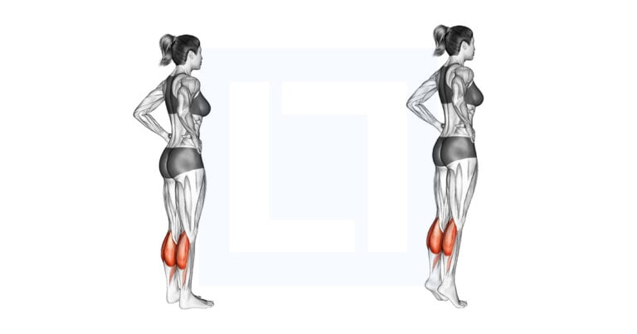

* Side Leg Raise – 12x per sisi

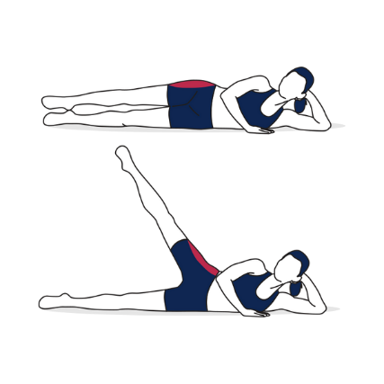

**Core (2 set)**:

* Plank – 30–60 detik

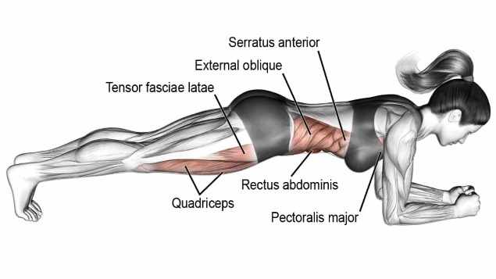

* Bird-Dog – 10x per sisi

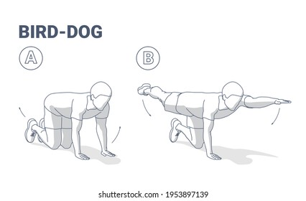

* Dead Bug – 10x per sisi

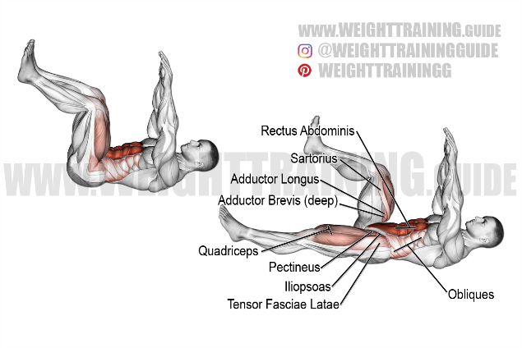

**(*Rest: 30–60 detik tiap set*)**